1. Purpose of the project
2. Scope of the work

* Create a dashboard of numbers that our dentists and managers can use to see how the business is doing

1. Stakeholders

* Clinic, everyone working in the clinic
* Jeremy – Project owner
* Managers
* Hr
* Dentists
* Support staff

1. Constraints

* As simple as possible
* Emphasizing security
* Budget constraints
* Time constraints
* Design constraints: recallmax, graph – data visualizations

1. Relevant Facts & Assumptions

* Data
* Database?

1. Estimated Cost
2. Risks
3. Time:

* Callouts:15 minutes w/ Jeremy

1. Any preferences about the website design
2. Type of data
   1. Numerical Data
   2. Number of patients, patients lost
   3. Production – per doctor
3. Data Visualization
   1. Recallmax
   2. Tabular
   3. Graphs that show the total profit and compare it
4. Requirements/Features
   1. How will you use this feature
   2. Is this feature a process?
   3. What is a successful feature? Measurement?
   4. Where does the process start?
   5. Where would the user access this feature?
   6. Where would the results be visible?
   7. How would the result be visualized?
   8. Any assumptions to make about this feature?
   9. What must happen before?
   10. What must happen after?

SWE-35

Dental intelligence:graphs(data visualization)

Only managers need access to this information

1. Non functional Requirements

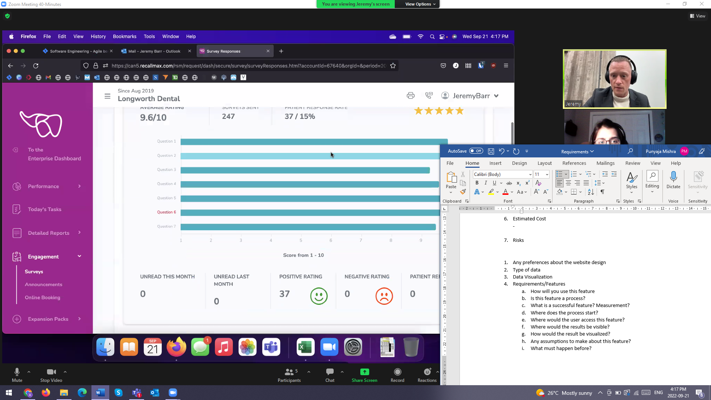

Comments from patients – implementing patient surveys - LATER